## Use Cases

Once finished all configuration, please set the environment to the sandbox.

We recommend you to perform the following tests:

* Place an order with the value more than 100,00 the ClearSale Status should be ‘Analyzing’.
* Place an order with the value between 50,00 and 100,00 the ClearSale Status should be ‘Reproved’.
* Place an order with the value less than 50,00 the ClearSale Status should be ‘Approved’.

To check the orders in ClearSale environments follow the steps below:

**Note:** Your sandbox client id is your user and the client secret is your password.

1. Look for search order on the <https://app.clear.sale> for production and <https://sandbox.clear.sale> for sandbox

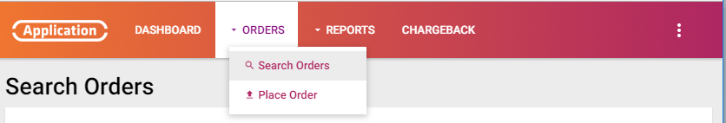

1. Search the order by number or data.

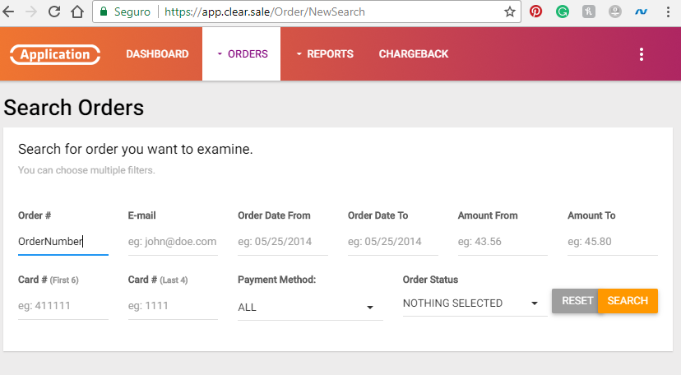

1. Check if the order is on the clearsale app.



